**PART II: NETWORK**

1. **Explorer: Explore latest blockchain data.**

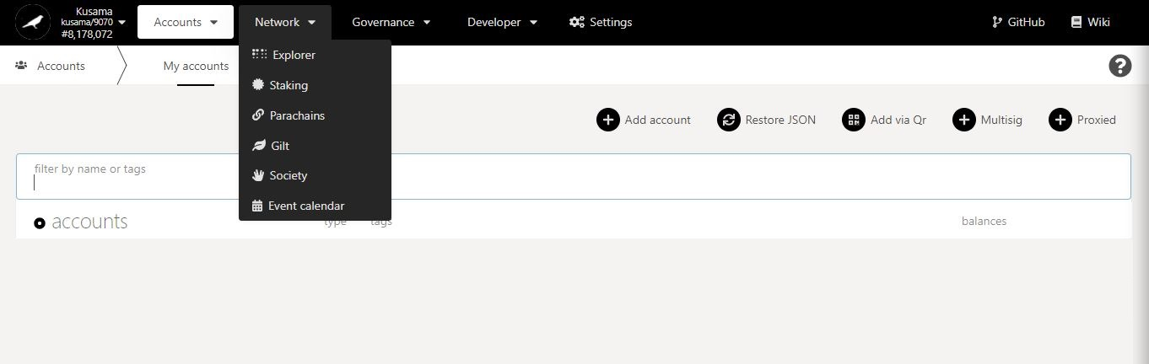

* 1. **View blockchain information.**

**Search** block hashes or block numbers.

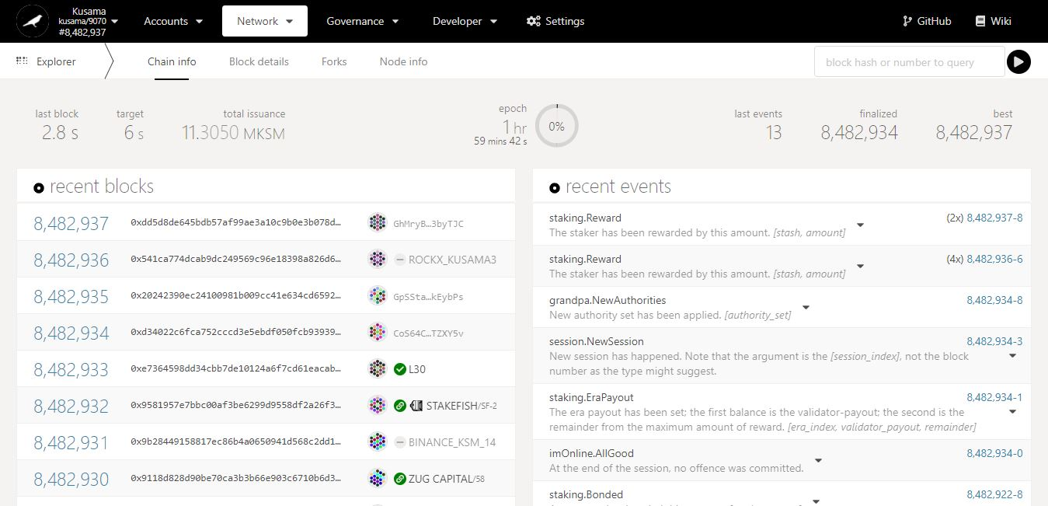

Recent **block hashes**.

Recent **block numbers**.

Key information on blockchain: **time elapsed since last block, targeted block time, total KSM supply, epoch countdown, blocks’ statistics.**

Recent **block validators**.

Overview of transactions/operations **included in recent blocks**.

* 1. **View block details.**

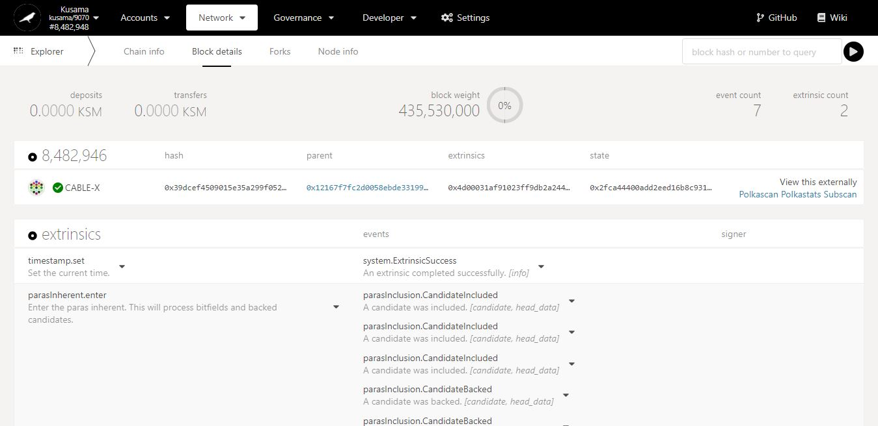

Extrinsics & Events in detail:

An event isa piece of data **from within the blockchain** (ex: issue a reward payout from my validator).

An extrinsic isa piece of data **from the outside world** (ex: claim a reward payout for my stash).

Key information on current block: **KSM amounts, block weight, and number of transactions.**

Overview of transactions/operations **included in this block**. Note: Click on the dropdown arrow to view each individual transaction/operation in greater detail.

* 1. **Monitor blockchain forks.**

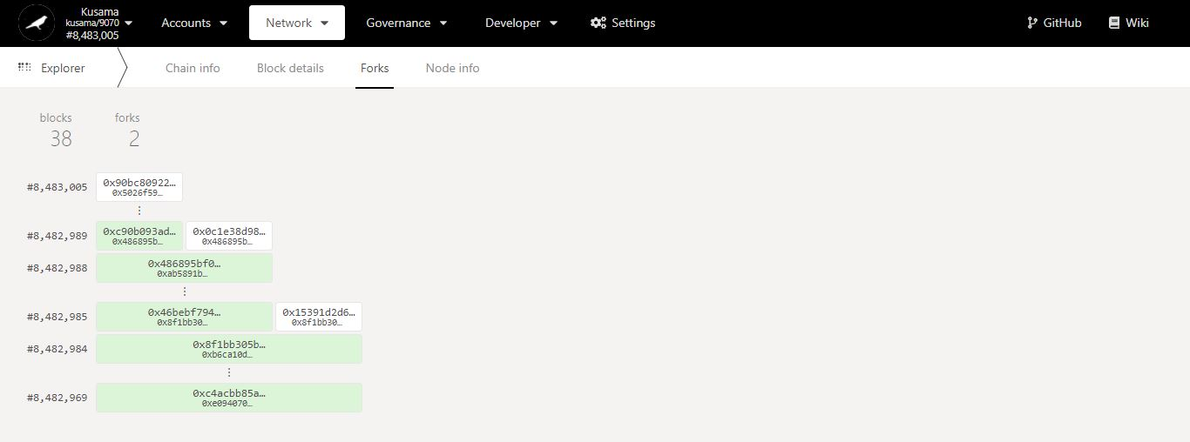

Key information on forks: **number of blocks captured, and number of forks encountered since monitoring started.**

Last **propagated** block number and block hash **(white colour)** captured by this node since monitoring started.

Last **finalised** block number and block hash **(green colour)** captured by this node since monitoring started.

**2nd fork.**

**1st fork.**

* 1. **Monitor blockchain nodes information.**

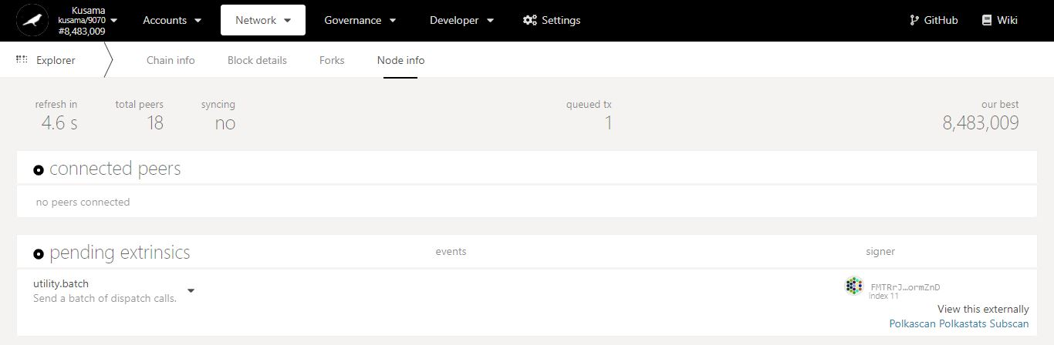

Key information on current node: **countdown to refresh, peer nodes, sync status.**

Latest block number **captured.**

**Sender(s)** of the transaction(s) in queue**.**

**Nature** of the transaction(s) in queue.

Number of **transaction(s)** in queue**.**

Number of node(s) **connected to this node.**